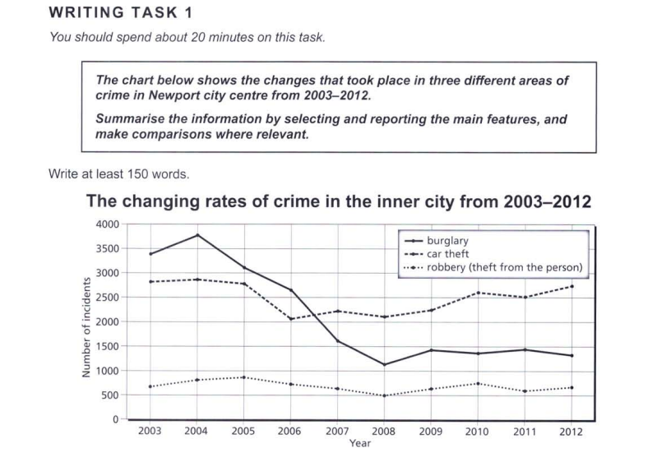

Essay Response:

The given graph shows the trends of three types of crime that took place in the Newport city centre, from 2003 to 2012. It contains information about the number of incidents of burglary, car theft, and robbery per year. Each of the mentioned variants display different trends, that are discussed below.

Firstly, burglaries increased between 2003 and 2004. But these numbers then plummeted by about 2500 in the next four years. After this rapid decrease, the figures for burglary have fluctuated around 1450 in the years after 2005. Burglaries were the top crime in the region, but since 2006, has been relegated to second place, after car theft incidents surpassed it.

Secondly, cases of car theft have fluctuated a lot in the 10-year timeframe displayed. The only notable changes were a decrease of more than 1000 incidents from 2005 to 2006, and the subsequent slow increase that followed.

Finally, robberies have not experienced huge changes in their occurrence, with their numbers staying between 500 and 1000 for all the years presented in the graph. It is consistently the least prevalent type of crime in the inner city, as could be observed in the chart.

Hence, the highest change was seen in burglary incidents, while car thefts stayed within a range of 1000 from the first recorded value in 2003. Robberies have stayed relatively constant, with a small variance over the ten years.